Dignity
Delicate Celebration
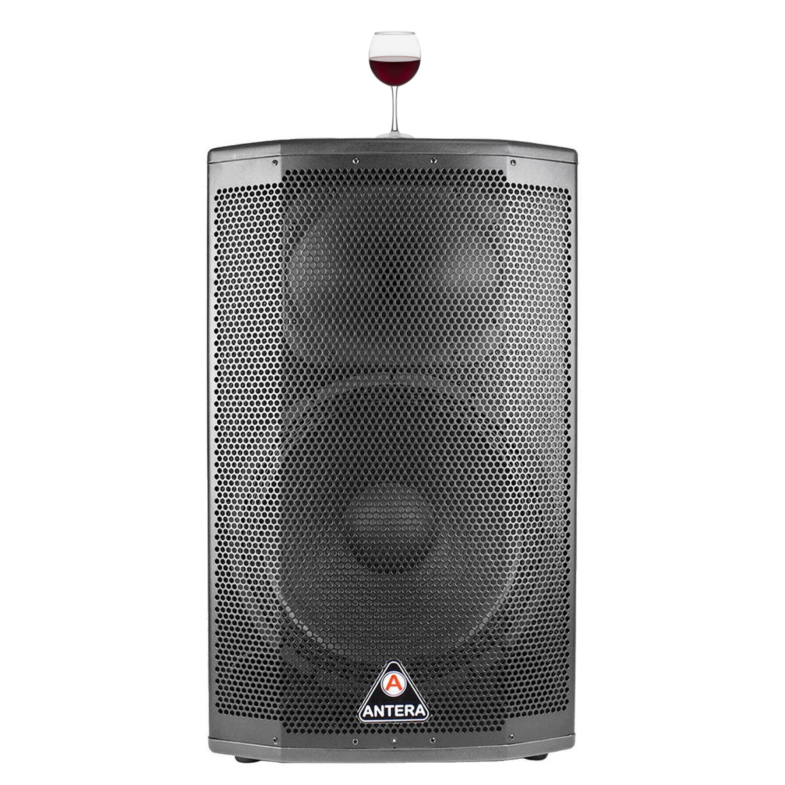

https://ecumenic.github.io/dignity-celebration
Dignity
Delicate Celebration

• Proposal:
Following the Ecumenic Creative Operations (https://ecumenic.github.io) methodology (https://github.com/ecumenic/project) we developed the program for a dignified inclusive accessible laic-interfaith crosscultural ethic multimedia gamified party.

• Project:
We believe that dignity is not a privilege and we seek fair prices for our services.
We believe that drunkenness gets in the way of ours and drink prices are progressive.
We believe in laic-interfaith harm-reduction holding humanitarian charitable services.
We believe in solidary economy accounting transparency and donate 50% of our profit.

• Program:
We respect party bohemia and work dilligently for you to have dignity and respect in it.
We respect relations and dialogue and celebrate dignified inclusivity in sound delicacies.
We respect our planet and seek to reduce our waste with recycling vegetarian dishes.
We respect good meetings and connect guests through a compassionate curatorship.
We respect democratic ethical free-thinking and promote a ballroomof poetic lectures.
We respect human rights and privace only allowing consensual medias recording.
We respect freedom accessibility and can recommend other parties without these rules.

• Procedures:
We demand respect for our party with our guests in their most dignified garments.
We demand respect for politeness regardless of origin, gender, position, or creed.
We demand respect for the truth, based on facts and data, in all talks and dialogues.
We demand respect for seduction and erotism not allowing open sexual performativity.

• Professionship:
We work with world renowned artists, artisans, scientists, and humanitarian academics.
We work with the best producers and products compliant to fair trade green logistics.
We work with precision schedules and methodologies seeking excellence transparency.

• Proposer:
We are the Ecumenic Creative Operations (https://ecumenic.github.io) art collective
and work under respectful compliance to world laic-interfaith compliance guidelines (https://github.com/ecumenic/project) to create open-source cultural developments.

• Contact For A Site-Specific Compliant Fundraising Budget Plan

